# **Rules**

## **2024 Summer Series Rules**

**Rules in Red have changed for the 2024 season**.

**Our rules will follow the 2024 ASN Canada Rules with the following amendments:**

* **TAG Senior will now list the Minimum Age as 15 years of age.**
* **TAG Junior will now list the Age Requirements as 12-14 years of age.**
* **Front brakes are not allowed on any kart other than in the Shifter Class.**
* **All engines other than in the Shifter Class will use a spec radiator. If no spec radiator is listed in homologation documentation, then a radiator with a maximum 135 square inches of cooling fin is to be used. A radiator with more than 135 square inches can be used if a blocking plate is placed on both sides to reduce the available fin area to 135 square inches.**
* **No leaded fuel for all VIKA 2024 events**
* **Any member competing in the Summer Series will have their worst points race removed (“thrown away”) from their points total at the end of the Summer Series. The final race of the Summer Series is not eligible for this “throw away”.**
* **The Sportsman Class is a noncompetitive senior class for members who need additional practice time before moving into their respective classes. The Sportsman Class includes all engine packages and will not have a points structure or award trophies. Any member wishing to enter this class must discuss with Race Officials prior to entry. Race Officials have the discretion to place members in the Sportsman class. No Tech is required in this class as there are multiple engine packages used.**
* **Helmets have been updated to no longer include 2010 or older helmets. See list of approved helmets in section 2.4 below.**

[View latest ASN CANADA - Canadian Karting Regulations](https://www.asncanada.ca/karting)

**2024 Competition Classes & Weights are listed below, 2024 changes are in Red.**

**\*\*\*\*\*\*\*\*\*\*\*\*\*\*\*\*\*\*\*\*\*ADD THE CLASS PDF HERE\*\*\*\*\*\*\*\*\*\*\*\*\*\*\*\*\*\*\*\*\***

# **VIKA Supplementary Competition Rules**

# **Approved for 2024**

The information contained within this rule package is intended as a supplement to the ASN CANADA FIA GENERAL COMPETITION REGULATIONS and may be incomplete and is subject to change by the club executive without further notice. Where there is a conflict between the rules stated herein and ASN rules, these rules shall take precedence. To completely understand the scope of the entire club rules contract, it is recommended that all members acquire and familiarise themselves with the rules as set out in the ASN competition regulations and technical manual. For interpretation or clarification of these rules contact the Race Director.

## **1.0 INTRODUCTION**

Vancouver Island Kart Association, further referred to as VIKA, is a private membership club incorporated as a not for profit society with the mandate to promote the sport of karting.

VIKA Rule book consist of 2 parts:

Part 1: General club rule set including rules and regulations for practising with VIKA on non-racing dates.

Part 2: Competition rule set including rules and regulations for club racing with VIKA.

Both rule sets work in conjunction with each other. Please read them carefully and familiarise yourself to avoid confusion and disappointment while practising and racing with VIKA.

If it is not listed in this rule book, assume it is not allowed.

## **2.0 GENERAL**

### **2.1 RELEASE OF LIABILITY**

All persons who enter the premises must sign a “RELEASE OF LIABILITY” form before being allowed on the premises.

All visitors, drivers, officials, mechanics, and parents of juniors are required to sign the “RELEASE OF LIABILITY” form.

At race weekends all spectators entering the facility must obtain a wristband and sign the general waiver. Spectators must not enter restricted areas of the facility without having obtained a wristband from registration.

Restricted areas include, but are not restricted to the: racing surface, run off areas, grid area, scale area, tech area, timing, scoring, flagging stands and any other area used to run the event. Generally anywhere other than the parking lot and the grandstands at the entrance to the property.

All minors must submit a “RELEASE OF LIABILITY” and “HOLD HARMLESS AGREEMENT” at any time an adult would have to sign a “RELEASE OF LIABILITY”.

All competitors, mechanics, etc. must sign the “RELEASE OF LIABILITY” and “HOLD HARMLESS AGREEMENT”.

Upon payment of entry fees, the Registrar will issue the appropriate armbands and Tech Sheets.

### **2.2 MEMBERSHIP**

Membership is a privilege and is not a right.

A membership is required for drivers to participate within the club's races.

A one day licence is available. A fee will be charged for a one-day licence. No licence is required for open practice days.

To compete in a club event, entrants must meet the requirements below:

Be a current member in good standing of the club or possess a valid day membership, or

Be a member of an affiliated club that VIKA has a reciprocal agreement with.

Drivers must meet the criteria set forth in the CLUB COMPETITION CLASSES.

Members who do not comply with the VIKA rules may be subject to an immediate loss of their practice privileges or other sanction recourse without any refunds of paid membership dues. Drivers are responsible for the conduct of their crew and spectators.

Penalties of membership are assessed and adjudged by the VIKA Executive without recourse by the offender.

### **2.3 TRACK OPERATIONS**

Karts, ATVs, scooters, bikes, skateboards, and other non-medical mobility devices are not to be operated in the pit area or on the track.

Karts being pushed on kart stands to the hot pit area are not permitted to be running.

Karts are not to be operated under their own power in the pit area at any time. Must be in control and outside of your kart.

Parking on site is not guaranteed, parking is permitted to paying customers on a first come, first serve basis.

VIMC does not allow pets on the premises.

### **2.4 SAFETY EQUIPMENT**

Driver’s safety equipment to be as per ASN Canada FIA Sporting Regulations and or approved safety apparel determined during pre-race tech.

During all on track sessions, including practices, drivers must wear the required driver’s racing equipment as defined in these regulations.

**Allowable Helmets Helmets must comply with the following prescriptions: For drivers under 15 years old: Snell-FIA CM (Snell-FIA CMS2016 and Snell-FIA CMR2016) For drivers over 15 years old: Snell-Foundation K2015, K2020, SA2015, SA2020, M2015, M2020R, M2020D FIA 8859-2015, FIA 8860-2010, FIA 8860-2018, FIA 8860-2018-ABP Snell-FIA CM (Snell-FIA CMS2016, Snell-FIA CMR2016).In accordance with Appendix L of the FIA International Sporting Code (Chapter III, Article 1.4), the addition of any device to a helmet, aerodynamic or otherwise, is allowed if it was homologated with the helmet concerned. Helmets that meet the Snell-FIA CM/CMH standards may continue to be used by drivers after 15 years of age without limitation. The document 2023-ASN-C**

If hair extends appreciably from beneath helmet level to present a safety concern in the opinion of event race officials, it is mandatory that participants wear a balaclava or head-sock to prevent hair from extending outside the helmet.

Apparel items such as bandanas, sweater hoods, loose belts, etc., even inside the racing suit, are not permitted.

Drivers are required to wear racing suits designed for karting use for all events. Racing suits must cover the whole body, legs and arms included. The suit must be completely fastened as designed. A driver with exposed skin on arms or legs may be shown the Black Flag with Orange Disk. Abrasion resistant gloves must completely cover the hands and wrists. Abrasion resistant shoes must cover the feet and protect the ankles.

### **2.5 MECHANICS**

Must have wristbands and sign waivers to be in the hot pit.

### **2.6 NOISE**

Maximum kart engine sound level permitted is 82db as measured in accordance with VIKA specifications.

All karts are to be equipped with an air box and an appropriate silencer. Note: Some engine packages may not require an additional silencer, but it is the driver’s responsibility to ensure their engine does not exceed the 82 db level. (Measured 100’ perpendicular to the straightaway at a height of 3’) as determined by the VIKA Executive or their designated authorities.

All karts must use an air box with the exception of kid karts and 4 Cycle engines. CIK classes must use an approved air box.

### **2.7 PIT SPACES**

All pits will require: Fire extinguisher, drain pan, garbage container.

All asphalt surfaces are to be protected and kept free of debris at all times. It is also recommended that a tarp/carpet be placed under any area a kart will be worked on.

To prevent asphalt and other surfaces from becoming contaminated with fuel/oil or other harmful products, DRIP PANS must be used at all times.

Floor dry must be applied to all spills immediately and cleaned up before the racer leaves the site.

Event Organisers shall provide absorptive products for spills.

Damaged kart parts, tires, used fuel containers and any other discard-able material are to be removed from the facility on completion of practice.

All fluids (fuel, oil, lubricants, cleaners, etc.) are to be removed from the facility on completion of practice or race.

NO disposal of fuel/oil, or fuel containers on site.

All safety wire, tie straps, etc. are to be picked up and put into the garbage at all times.

Trailer tongues to be supported. i.e. set on a board so they don’t dig into the pavement.

Entrants/users of the facility are responsible for putting garbage in the garbage bin.

Pit spaces must be left clean at the end of the event.

Tent pegs are not allowed to be used to secure tents on paved surfaces.

A first aid kit is highly recommended.

Pit spaces may be assigned or organised by the VIKA executive for all practice and race dates.

# **3.0 SUPPLEMENTARY COMPETITION RULES**

### **3.1 COMPETITION CLASSES**

<https://vika.ca/rules.html>

### **3.2 KART ENTRY FEES**

Refer to the most recent event registration information.

### **3.3 MEMBERSHIP FOR COMPETITION**

Only VIKA Club members in good standing will receive Club Championship Points.

### **3.4 TRACK ACCESS**

All drivers must have a valid wristband prior to accessing the hot pit area and race track.

Kart displaying a current tech sticker on Nassau panel or band on the right front spindle, and

Submitting a tech card to the Safety Tech inspector(s).

If a driver is caught on the racing circuit at any time without Tech Approval or a valid wristband, they may be disqualified for the day.

### **3.5 REFUNDS**

### **We do not issue refunds after race registration closes.**

### **3.6 WORKERS/STAFFING**

A general, limited description of VIKA Club Roles is provided below.

Race Director: The Race Director will be that official having complete charge of all race officials, technical inspectors, turn marshals, the track and karts during the event. The Race Director will disqualify or penalise, through signals from the flagman, any driver who in their opinion, or that of their observers, is in violation of the rules or whose kart is or has become unsafe. The decisions made by the race director to warn, penalise, or disqualify any driver is not eligible for protest. The Race Director may shorten any race before karts have left the grid. All events will have a race director appointed and will be introduced at the drivers meeting.

Assistant Race Director: This official will work directly with the Race Director and serves as an additional set of eyes and ears. It is up to the Race Director to allow or not allow the Assistant Race Director to make on track decisions.

Head Flagman: The Head Flagman is the official in complete charge of the flags at the start/finish line. The Head Flagman will adhere to the rules and regulation in this manual as well as following the instructions from the Race Director. The Head Flagman’s signals are to be obeyed without exception. If necessary, the Head Flagman will conduct a meeting for all drivers prior to the start of the event to explain the flags, their use, and rules.

Corner Marshalls: Corner Marshals will be strategically placed around the track to use flags, as instructed and when necessary, to signal drivers to hazardous situations. Corner Marshals will also report any rule infraction to the Race Director. It is not the duty of the Corner Marshall to assist drivers at the scene of the accident or incident in separating their karts or getting them underway. Their responsibility lies in warning oncoming traffic to a hazardous situation, and informing race control of the need for additional resources. Corner Marshals shall be at least 18 years of age.

Grid Steward: The Grid Steward shall be that official(s) having the charge of the Grid area. It is the Grid Steward’s responsibility to keep all unauthorised person(s) out of restricted areas, grid classes, and report any issues to the race director.

Head Technical Inspector/Director: The Head Technical Inspector will be that official having charge of pre- and post-race inspections in a designated area where technical inspections are performed. They are solely responsible for appointing Assistant Technical Inspectors. The Head Technical Inspector will designate an area, the “Impound Area”, where karts and drivers will be checked for minimum class weight, fuel legality, maximum kart size, engine legality, exhaust system legality, body work specifications, legal attachment of weights, etc. Post-race scale and tech areas are off limits to person(s) other than the competitor. Competitors are under the direction of the Head Technical Inspector or their designee while in the inspection area. Entrants that leave the inspection area without the approval of the Head Technical Inspector or their designee, are subject to disqualification.

Chief Scorer: The Chief Scorer is the official responsible for all timing and scoring of the event. The Chief Scorer will keep the Head flagman informed of positions, laps complete and or time of event.

The Race Director may levy penalties for infractions committed by a driver, crew, or any spectator associated with a driver. Penalties will be based on ASN Penalty Guidelines.

See Penalty information here: [ASN Penalty Guidelines](https://static1.squarespace.com/static/5ec3f6ee0e3c5849fde5aece/t/63f78b423d679d059b295c10/1677167426568/2023-ASN-CDN-Karting-Penalty-Guidelines.pdf)

The Race Director can request VIKA levy additional penalties.

### **3.7 PIT SAFETY**

The Safety Tech inspectors shall require the following safety and tech items at each pit area:

At least 1 (one) copy (digital or printed) of these VIKA Supplemental Club Rules for the current year.

### **3.8 NEW / ROOKIE KART DRIVERS**

All NEW/ROOKIE drivers must wear a contrasting colour X on the back of their helmet. Their kart must be equipped with a contrasting X on the rear number panel.

All NEW/ROOKIE drivers will start in the Sportsman Class. This class will include TAG and 4 Cycle karts. Drivers will run in this class until they can maintain a minimum lap time as decided by the Race Director. Once a driver has been moved into their appropriate racing class, they will still be identified as a rookie and follow the following rules. Drivers will only be placed in the sportsman class at the discretion of the race director. No trophies or points will be awarded in this class, it is used for drivers to hone their race craft and get up to speed to race in their respective classes.

All NEW/ROOKIE drivers will start at the back of their class in all sessions for a minimum of 3 race days and/or at the discretion of the race director.

All NEW/ROOKIE drivers must attend an orientation session given by a VIKA member before practice on race weekends (this is also open to any driver wanting to attend).

After 3 races the Rookie/New driver can request to have the rookie status removed at the discretion of the Race Director.

3.9 KARTS OFF THE RACING SURFACE

Flagging Marshals / Race Officials may assist all cadet drivers.  
In Junior and Senior classes, once a kart has left the racing surface, and it can reasonably be assumed they are unable to re-enter the race track safely, the competitor must abandon their kart in the safest position possible, and move away from the racing surface.

### **3.10 POST RACE TECH**

There shall be absolutely no excessive speed in the shut-down area.

All karts must stop at or before the stop line/sign.

Absolutely no driving onto the scales

Driver and kart must weigh-in after qualifying and all subsequent races.

If a driver is found to be under-weight they will be disqualified from the current session only. No person shall be permitted to assist or meet with any driver prior to weigh-in without permission of the Scale Technician. Failure to comply may result in a driver being disqualified from the session.

All competitors must weigh-in except for medical reasons as a result of an on-track incident.

The Scale Marshal shall have the authority to determine weight legality.

All karts and drivers must proceed to tech and must be approved to receive points.

Fuel, tires, chassis, engine, and engine components may be subject to post race legality technical inspections at the discretion of the Technical Director or Race Director.

It is the driver’s responsibility to ensure they clear Tech before leaving the scale area.

### **3.11 TIRES**

All tires may be marked as per tech procedures at the discretion of the Technical Director.

Any tires, which have not been approved for replacement by the Technical Director, or do not display the proper tech marking, shall be considered illegal.

Tires checked with a durometer may not be more than 5 points lower than the factory known readings. Tires to be checked when the core temperature is 70°F.

No tire warming allowed.

Any kart that has illegal compound tires for its class will be denied access to the grid prior to the start of the race.

Tire treatment (ie: doping) is not allowed. Only VIKA approved tires may be used. Refer to <https://vika.ca/rules.html> for approved tires.

Current approved tires as follows:

** Full Size chassis classes : MoJo ( D2,D5 ), LeCont ( FZ LP White Prime, FZ LO Red Option, SVB Red Option ), LeVanto ( KRT ), Vega Blue Nordam ( ONT / SL3 )

* Kid Kart / Cadet Chassis classes : Rotax Micro, Mini and Tag Cadet use only Mojo ( D2 ), LeCont ( FZ LO Red Option, SVB Red Option), LeVanto ( KRT )

NOTE : Rain Tires are open for all classes. Any of the above compounds may be used in any classes unless specified.

### **3.12 ENGINE**

All engines must conform to current class rules listed at <https://vika.ca/rules.html>

The Race Director and Technical Director reserve the right to impound any engine and seal it for technical inspection at a later time. Refusal to comply with the technical inspection request shall result in disqualification from the current event and possible additional membership penalties.

### **3.13 BALLAST**

Ballast weight must be securely attached to the main Kart frame or seat. Mounting of ballast weight on bumpers or side bumper bars is not permitted. Bolts must be used to secure the ballast weights. Attaching bolts must be no less than 5/16” (8 mm) in diameter. A minimum of one attaching bolt is required for each 5 pounds of weight added. Attaching bolts must be securely fastened with one of the following methods: Single nut with cotter pin or safety wire Double nuts or Self-locking nuts – metallic or plastic type Large area washers must be used in the attaching of weights to the seat of the Kart, both inside the seat and outside of the ballast.

All ballast must be painted white and have the competitor kart number on it.

Ballast may be limited to a maximum allowed for Cadet, Micro, and Junior competitors. Maximum ballast will be determined by VIKA.

### **3.14 REAR BUMPER**

Wide rear bumpers are mandatory in all Junior and Senior classes as per ASN. All dimensions are covered in the ASN Technical Regulations.

In addition, VIKA requires a 5-inch minimum height on the outside edges and must be a plastic bumper; metal bumpers are no longer allowed.

All full size chassis must use a homologated rear bumper. 1040mm minimum width as per ASN.

### **3.15 FRONT BUMPER**

CIK approved Drop Down bumper system is REQUIRED.

Technical Drawings area available at this link: [Push Back Bumper Rules](https://static1.squarespace.com/static/5ec3f6ee0e3c5849fde5aece/t/63f78ac3a9af7036eacb7cf8/1677167300540/2023-ASN-CDN-Front-Fairing-Push-Back.pdf)

### **3.16 KART NUMBERS**

Kart numbers assigned at the beginning of the race season cannot be changed until the following season. Karters assigned racing numbers from the previous season will have a first right of use as long as they are a paid up member in good standing.

Kart numbers should follow ASN technical regulations. Any deviation from the ASN regulations must be approved by the Race Director or Technical Inspector prior to accessing the race track.

### **3.17 FLAGS:**

Unless otherwise notified by VIKA Officials, flags will be as follows:

Green Flag: Displayed at the start of a race or practice session, or to restart a race or practice session. Green flag signifies “all clear” and racing or practice can begin/resume.

Yellow Flag: Displayed when there is an unsafe condition in that part of the race track. A Waved Yellow is shown to signify an incident or emergency in that area. Drivers should take care, slow down if necessary, and be prepared to stop as needed to avoid the danger ahead. A Stationary Yellow is displayed to signify a hazard remains in the incident area. In Yellow Flag Zones, NO PASSING is permitted from the yellow flag station until either the driver has cleared the incident area or the driver has reached the next flagging station that is not displaying a yellow flag.

Red Flag: Displayed by all flagging stations to signify an on track incident or accident that requires the suspension of the current session. Drivers should slow down when safe to do so, raise their hand, and proceed with extreme caution to the pit lane for further instructions from race officials. Be prepared to stop immediately if instructed to do so. During a red flag, all drivers must stay with their karts unless authorized by a race official. Repairs to karts may only be performed on pit lane with authorization of a race official. Only Race Officials will be allowed on the race track during a red flag condition. Crew and Family may NOT enter the racing surface during a red flag unless instructed to do so by a race official.

White Flag: Waved White Flag is shown by the starter to signify that 1 lap remains in any session. This is a courtesy flag only, racers should not assume the next flag and always race to the checkered flag.

Checkered Flag: Waved Checkered Flag is shown by the starter to signify the end of a race or session. This flag will also signify the end of any timing and scoring for the current race or session. Upon passing the Checker Flag, assume the track is in a Yellow Flag condition and proceed safely to pit road for Technical Inspection if required.

Blue Flag (Blue Flag with Yellow Stripe): Waved Blue Flag is shown by the starter to signify a driver is about to be caught/passed by the leaders of a session or race. The driver receiving this flag should maintain a consistent line so the faster karts can pass without the session being affected. Failure to obey this flag may result in a black flag.

Black Flag: Waved Black Flag is shown by the starter to signify a driver should report to the designated off-track area and consult with race officials. A kart number may be displayed for clarification. Any driver who fails to obey the black flag after it has been displayed twice will be disqualified from the current session and additional penalties may be issued. The starter may use a rolled up black flag to provide a warning to a driver that if the current aggressive/unsafe driving continues, a waved black flag may be issued. Drivers receiving the waved black flag will no longer be scored and will received penalties based on the issue or incident.

Mechanical Black Flag: Waved Mechanical Black flag is shown by the starter to signify a driver should report to the designated off-track area due to a mechanical issue that is likely to cause a danger. A kart number may be displayed for clarification. Any driver who fails to obey the black flag after it has been displayed twice will be disqualified from the current session and additional penalties may be issued. Drivers receiving this flag should discontinue racing immediately and move off the racing line in a safe manner.

Warmup and Formation Laps: Waved Green Flag will be displayed by the starter with Standing Green Flags displayed at flagging stations for a Warm Up Lap. A Stationary Yellow Flag will be displayed during the formation lap. All karts should proceed to their grid position and form up for the start of the race.

All flags are used at the discretion of Race Officials, the starter, and corner workers. Decisions related to Black Flags can not be protested, all Race Official decisions are final.

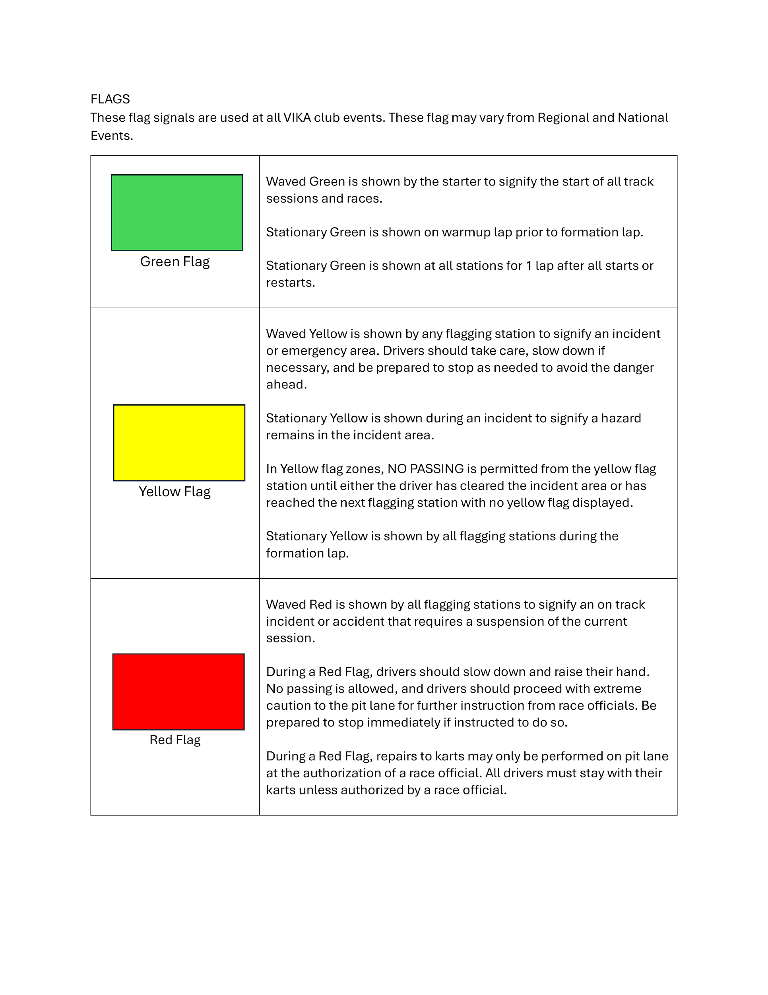

[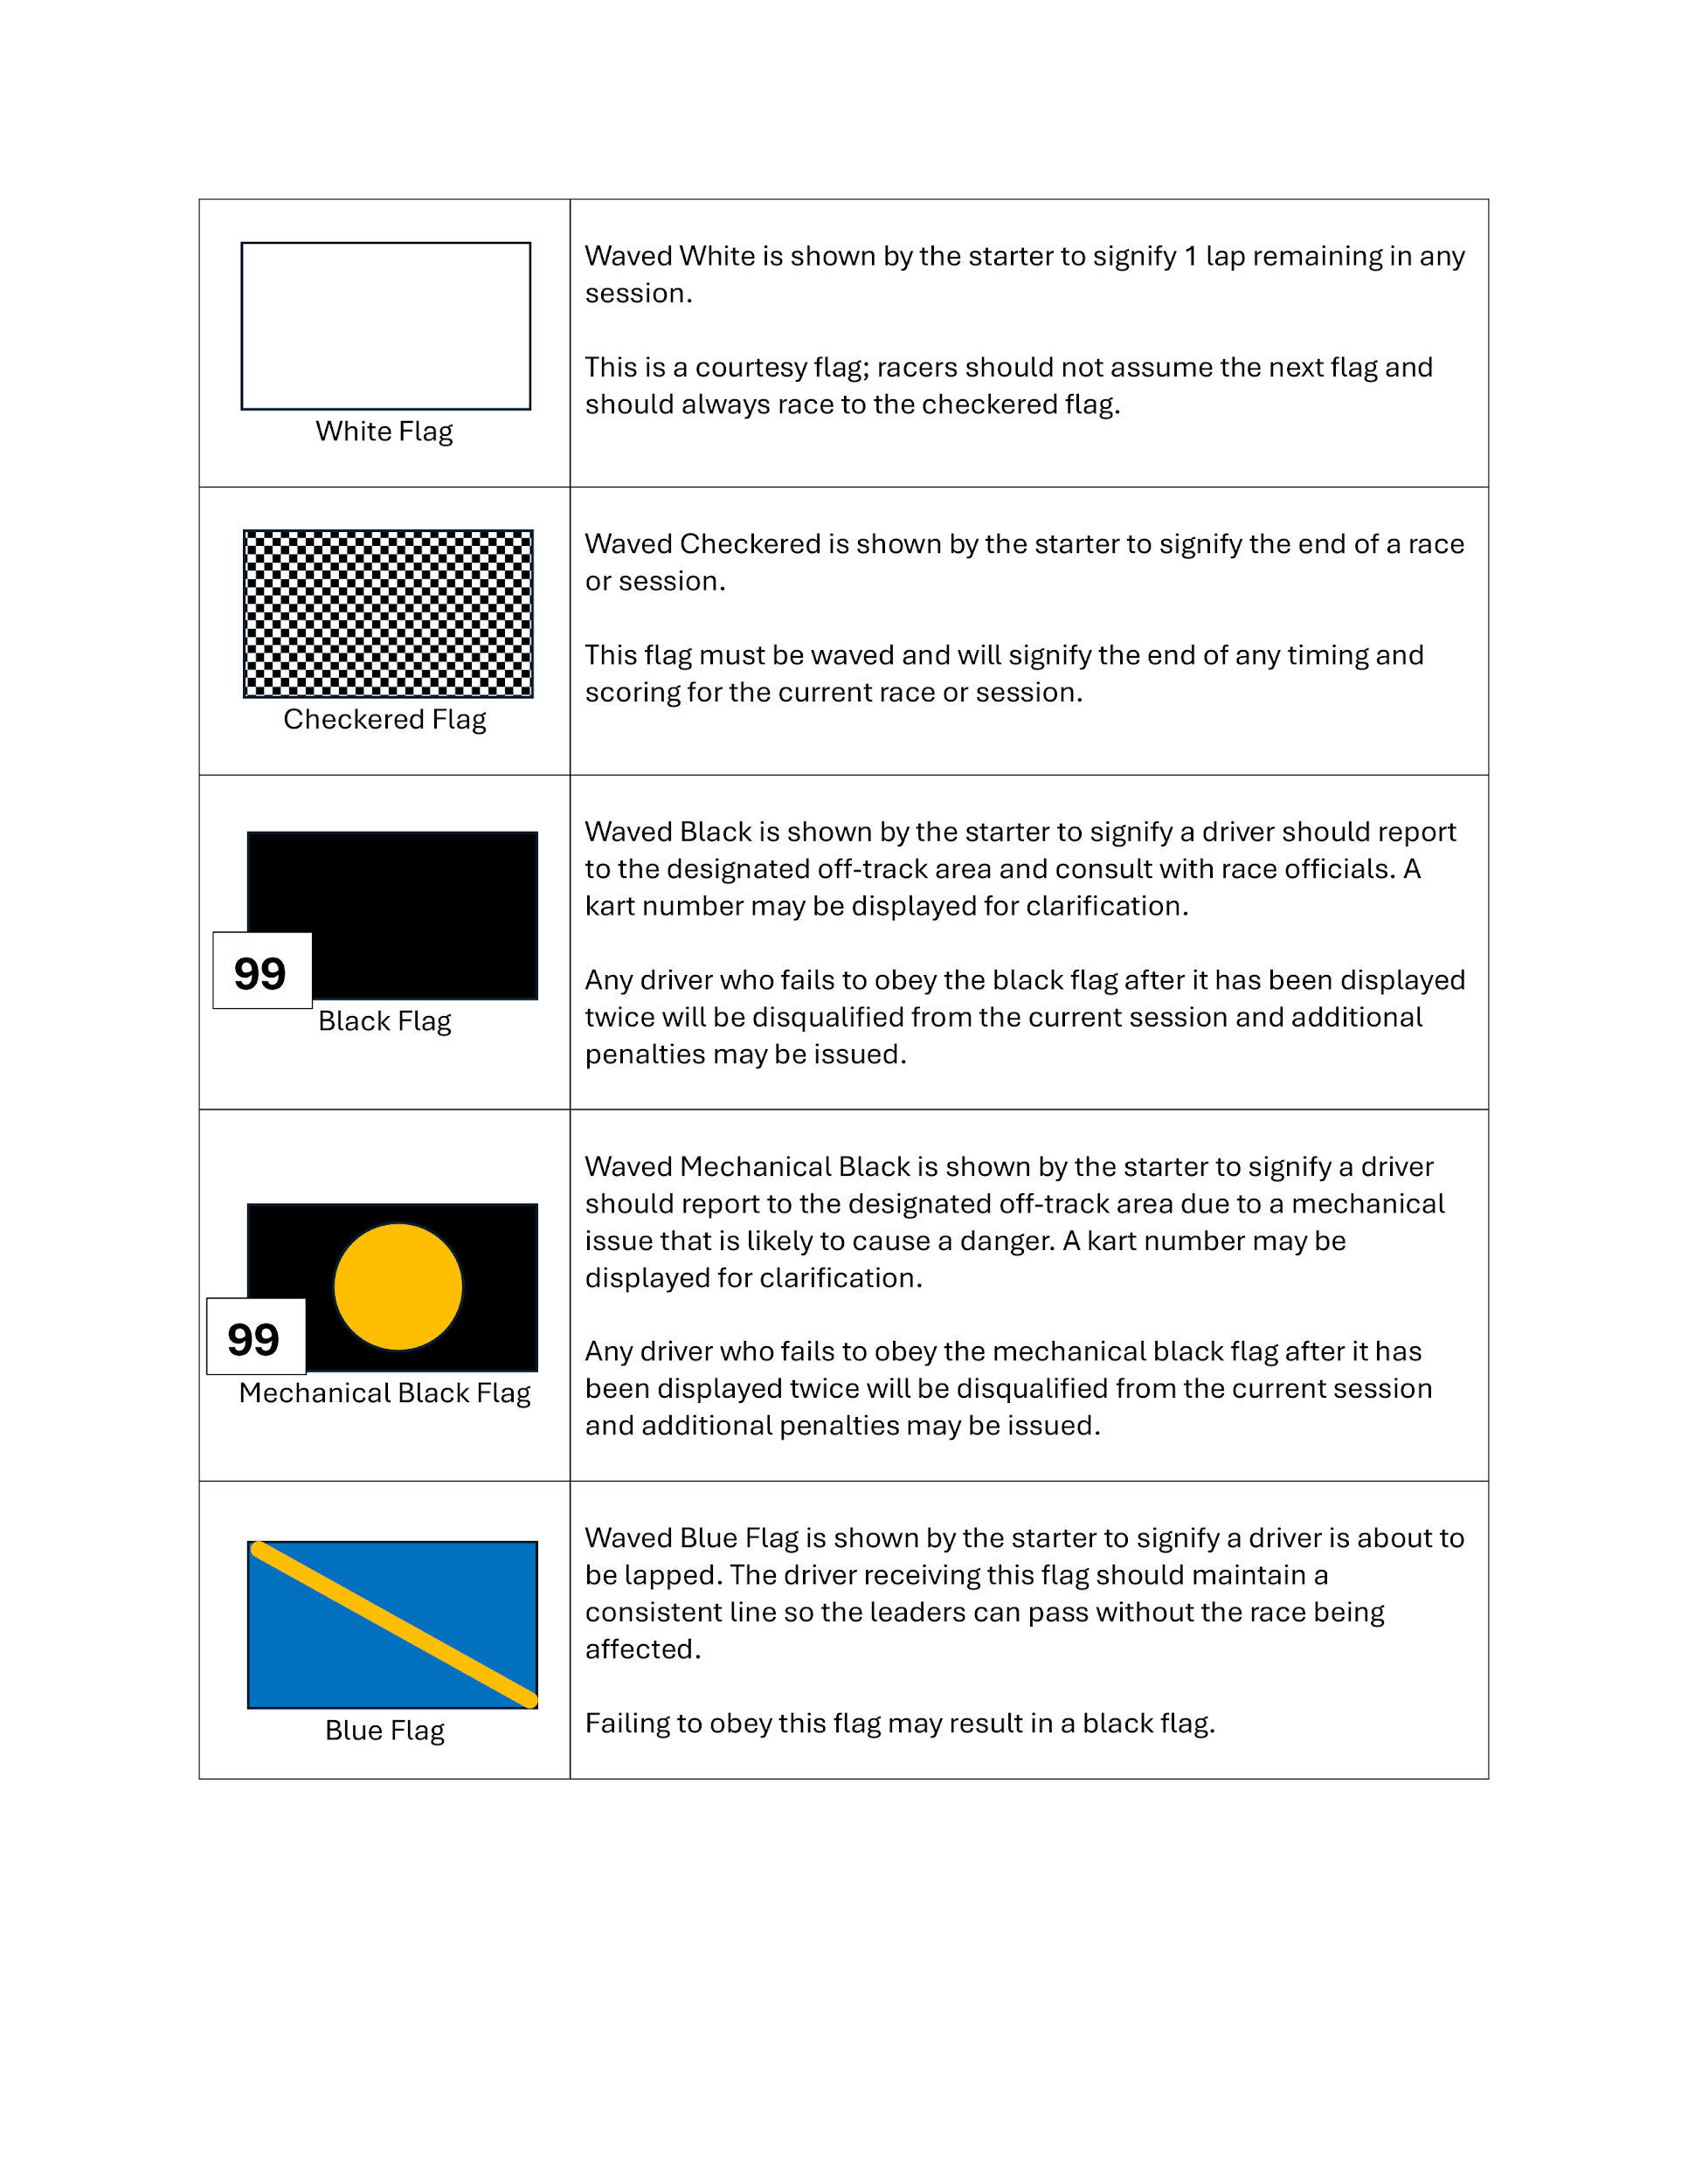](https://vika.ca/assets/img/VIKA/flags1.png)

### **Senior 4 Stroke Open Class Rules**

All Drivers to be VIKA members and must adhere to the current VIKA Competition Rules with the following supplementary rules:

• A single motor to be 4-Cycle and each kart not to exceed a cubic capacity (cc) of 210 cc. All modifications are allowed but must run gasoline only. Engines must not be run on Alcohol. Shifter karts are NOT permitted.

• There is no tire rule in this class, all tires are allowed.

• This class will provide its own Trophy sponsor

[KID KART CLASS SUPPLEMENTAL RULES](https://vika.ca/assets/documents/2023-VIKA-Kid-Kart-Class-Supplemental-Rules-1.pdf)